NAME: KAVITAPU SWARNA VARSHINI
REG.NO: 192324081
DATE: 14-07-2026

Write a python program for Tic-Tac-Toe Game
AIM: To write a Python program to implement a Tic-Tac-Toe Game for two players.
ALGORITHM:
- Create a 3×3 game board.
- Allow two players (X and O) to enter their moves alternately.
- Update the board after each valid move.
- Check for a winner or a draw after every move.
- Display the game result.
CODE:
board = [' '] * 9

def show():
print(board[0], "|", board[1], "|", board[2])
print("--+---+--")
print(board[3], "|", board[4], "|", board[5])
print("--+---+--")
print(board[6], "|", board[7], "|", board[8])

def win(p):
w = [(0,1,2),(3,4,5),(6,7,8),
(0,3,6),(1,4,7),(2,5,8),
(0,4,8),(2,4,6)]
return any(board[a]==board[b]==board[c]==p for a,b,c in w)

player = 'X'

for _ in range(9):
show()
pos = int(input("Enter position (1-9): ")) - 1

if board[pos] == ' ':
board[pos] = player

if win(player):
show()
print(player, "Wins!")
break

player = 'O' if player == 'X' else 'X'
else:
print("Position already taken.")
else:
show()
print("Game Draw!")
OUTPUT:
| |
--+---+--
| |
--+---+--
| |
Enter position (1-9): 3
| | X
--+---+--
| |
--+---+--
| |
Enter position (1-9): 2
| O | X
--+---+--
| |
--+---+--
| |
Enter position (1-9): 6
| O | X
--+---+--
| | X
--+---+--
| |
Enter position (1-9): 4
| O | X
--+---+--
O | | X
--+---+--
| |
Enter position (1-9): 9
| O | X
--+---+--
O | | X
--+---+--
| | X
X Wins!
IMAGE:
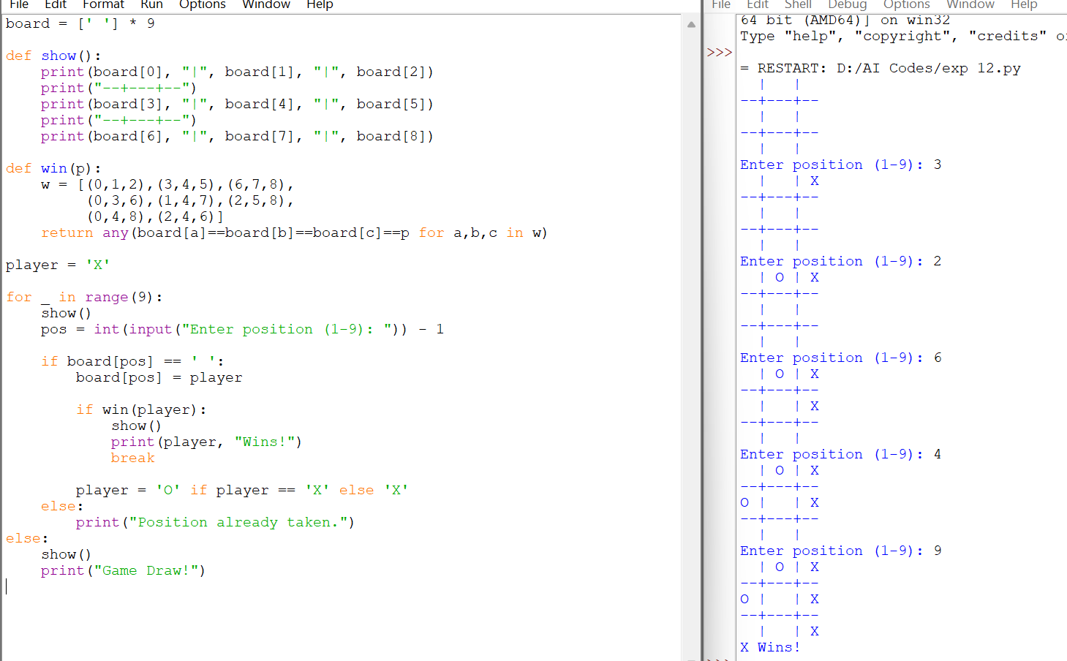

RESULT:
The Python program successfully implemented the Tic-Tac-Toe Game. It allowed two players to play alternately, checked for winning conditions after each move, and correctly displayed the winner or declared the game as a draw.

